Prepare Sample Data To Practice SQL Skill.
Sample Table – Worker
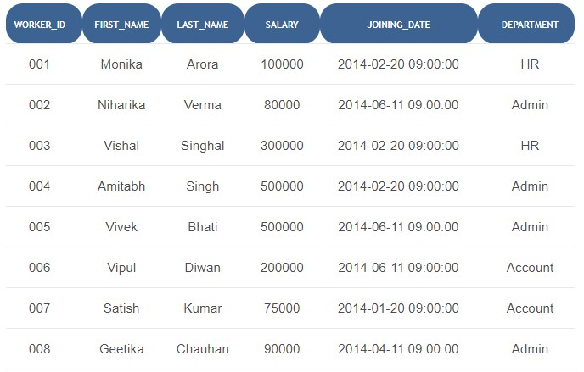
Sample Table – Bonus
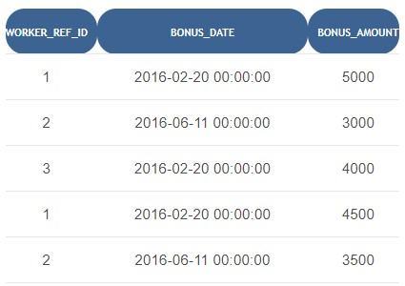
Sample Table – Title
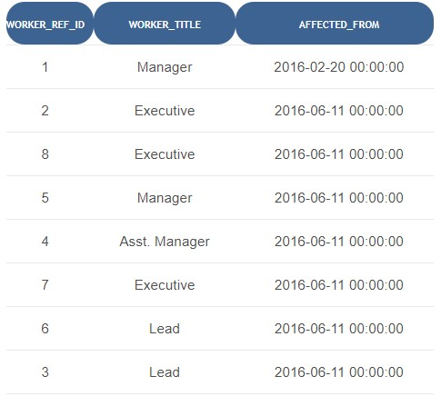

Query to create these three tables.
CREATE DATABASE workshop;
USE workshop;
For worker table:
CREATE TABLE Worker (
WORKER_ID INT PRIMARY KEY,
FIRST_NAME VARCHAR(50),
LAST_NAME VARCHAR(50),
SALARY INT,
JOINING_DATE DATE,
DEPARTMENT VARCHAR(50)
);
INSERT INTO Worker VALUES
(1, 'Monika', 'Arora', 100000, '2014-02-20', 'HR'),
(2, 'Niharika', 'Verma', 80000, '2014-06-11', 'Admin'),
(3, 'Vishal', 'Singhal', 300000, '2014-02-20', 'HR'),
(4, 'Amitabh', 'Singh', 500000, '2014-02-20', 'Admin'),
(5, 'Vipul', 'Diwan', 200000, '2014-06-11', 'Account'),
(6, 'Satish', 'Kumar', 75000, '2014-01-20', 'Account');

For bonus table:
CREATE TABLE Bonus (
WORKER_REF_ID INT,
BONUS_AMOUNT INT,
BONUS_DATE DATE,
FOREIGN KEY (WORKER_REF_ID) REFERENCES Worker(WORKER_ID)
);
INSERT INTO Bonus VALUES
(1, 5000, '2016-02-20'), (2, 3000, '2016-06-11'), (3, 4000, '2016-02-20'),
(1, 4500, '2016-02-20'), (2, 3500, '2016-06-11');
For Title table:
CREATE TABLE Title (
WORKER_REF_ID INT,
WORKER_TITLE VARCHAR(50),
AFFECTED_FROM DATE,
FOREIGN KEY (WORKER_REF_ID) REFERENCES Worker(WORKER_ID)
);
INSERT INTO Title VALUES
(1, 'Manager', '2016-02-20'),
(2, 'Executive', '2016-06-11'),
(3, 'Lead', '2016-02-20'),
(4, 'Assistant', '2016-02-20'),
(5, 'Manager', '2016-06-11'),
(6, 'Executive', '2016-01-20');
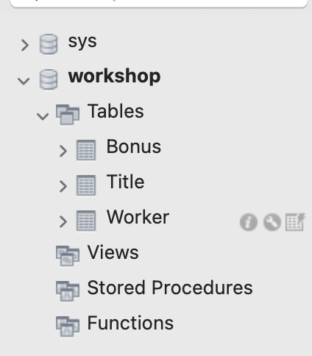

SQL Query Questions for Practice

Write an SQL query to fetch “FIRST_NAME” from Worker table using the alias name as <WORKER_NAME>

SELECT FIRST_NAME AS WORKER_NAME
FROM Worker;
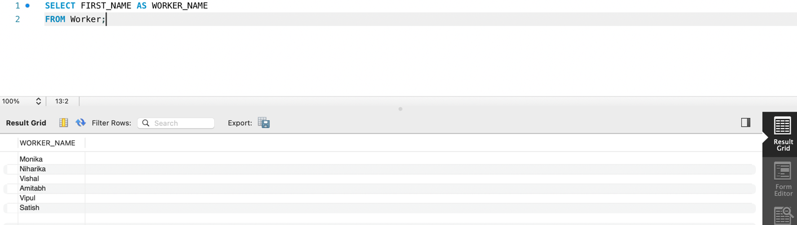

Write an SQL query to fetch “FIRST_NAME” from Worker table in upper case

SELECT UPPER(FIRST_NAME)
FROM Worker;
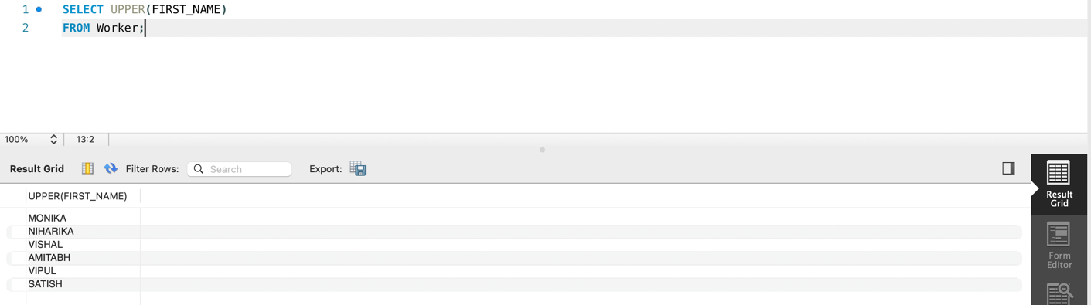

Write an SQL query to fetch unique values of DEPARTMENT from Worker table

SELECT DISTINCT DEPARTMENT
FROM Worker;
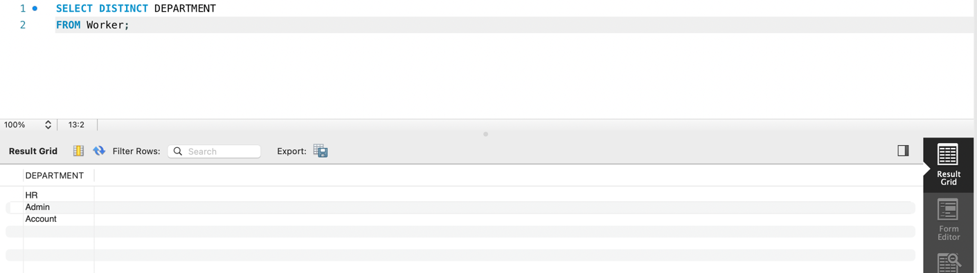

Write an SQL query to print the FIRST_NAME and LAST_NAME from the Worker table into a single column COMPLETE_NAME. A space char should separate them

SELECT CONCAT(FIRST_NAME, ' ', LAST_NAME) AS COMPLETE_NAME
FROM Worker;
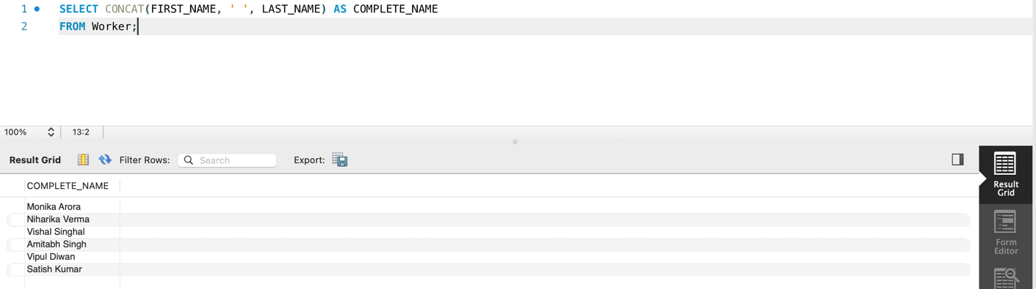

Write an SQL query to print all Worker details from the Worker table order by FIRST_NAME Ascending

SELECT *
FROM Worker
ORDER BY FIRST_NAME ASC;
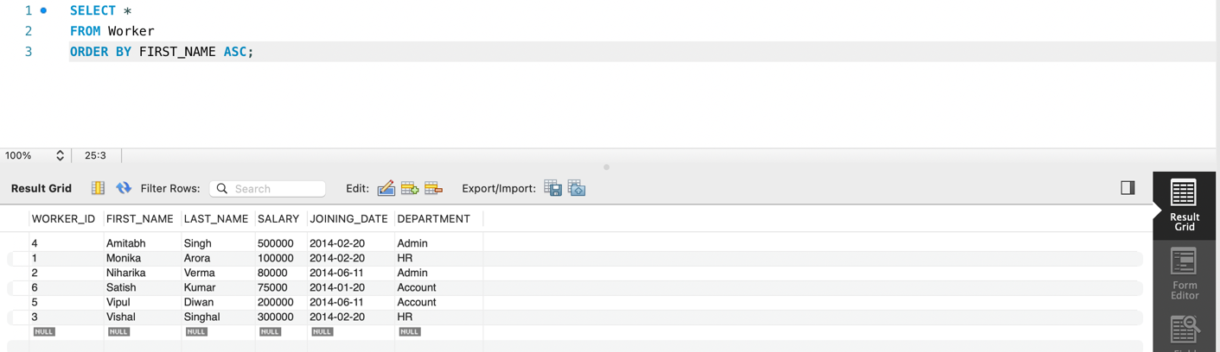

Write an SQL query to print all Worker details from the Worker table order by FIRST_NAME Ascending and DEPARTMENT Descending.

SELECT *
FROM Worker
ORDER BY FIRST_NAME ASC, DEPARTMENT DESC;
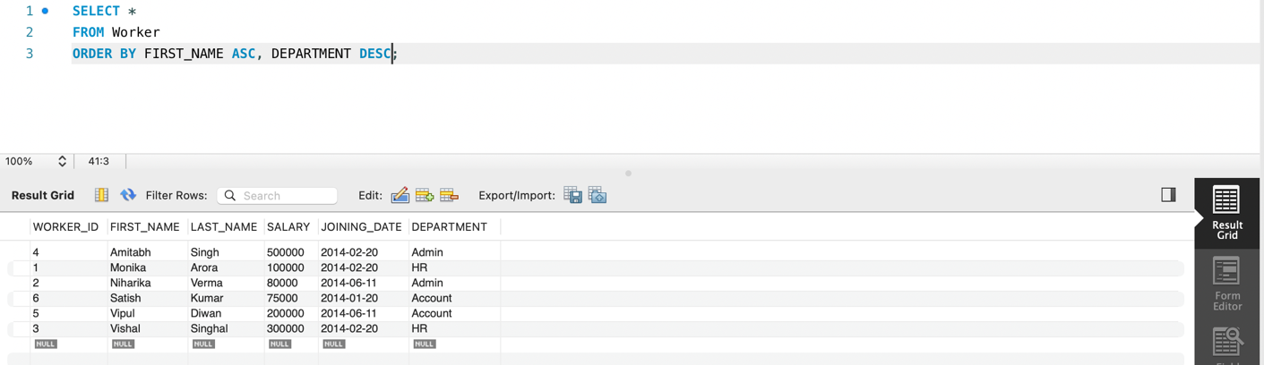

Write an SQL query to print details for Workers with the first name as “Vipul” and “Satish” from Worker table

SELECT *
FROM Worker
WHERE FIRST_NAME IN ('Vipul', 'Satish');
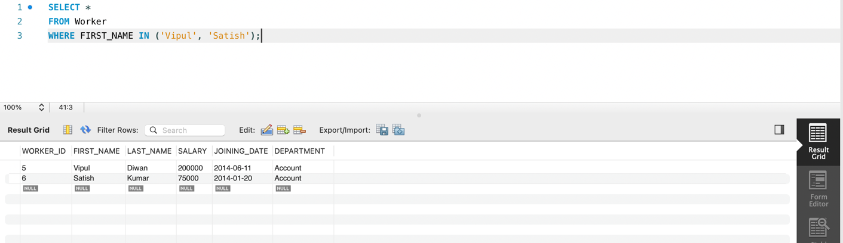

Write an SQL query to print details of workers excluding first names,

“Vipul” and “Satish” from Worker table

SELECT *
FROM Worker
WHERE FIRST_NAME NOT IN ('Vipul', 'Satish');
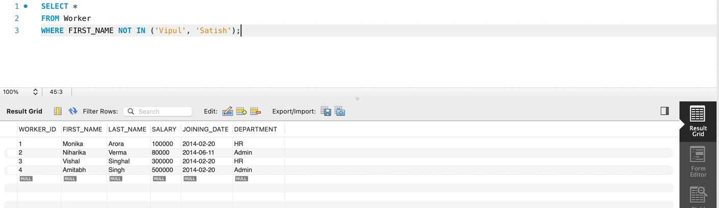

Write an SQL query to print details of the Workers whose FIRST_NAME contains ‘a’

SELECT *
FROM Worker
WHERE FIRST_NAME LIKE '%a%';
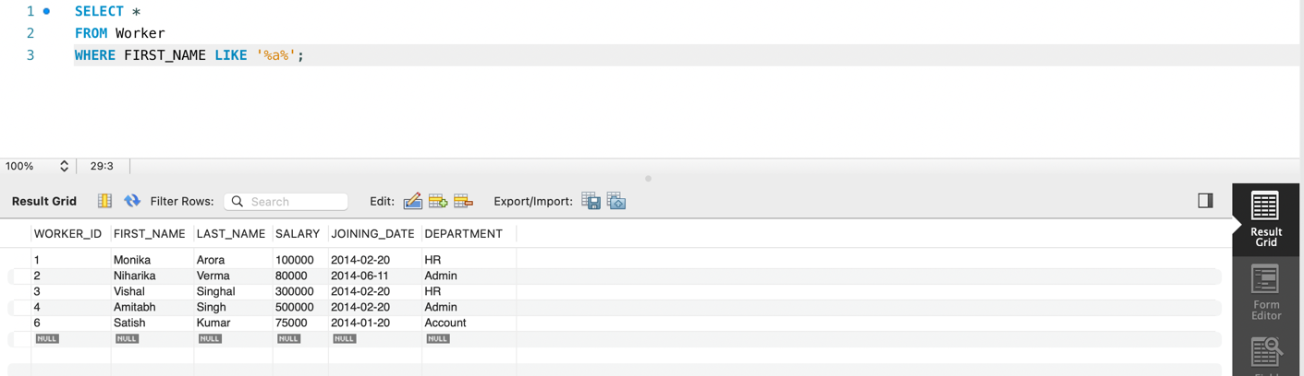

Write an SQL query to print details of the Workers whose SALARY lies between 100000 and 500000

SELECT *
FROM Worker
WHERE SALARY BETWEEN 100000 AND 500000;
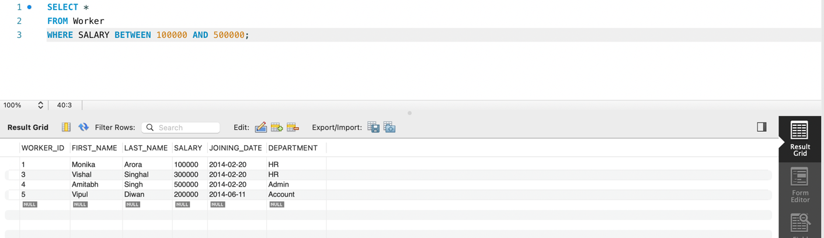

Write an SQL query to fetch the count of employees working in the department ‘Admin’

SELECT COUNT(*) AS TOTAL_EMPLOYEES
FROM Worker
WHERE DEPARTMENT = 'Admin';
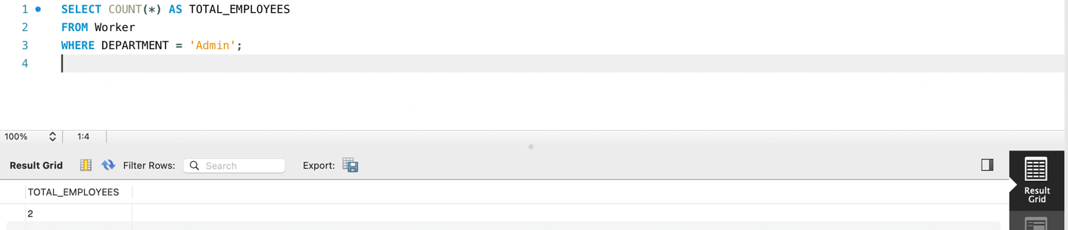

Write an SQL query to show the top n (say 10) records of a table

SELECT *
FROM Worker
LIMIT 10;
